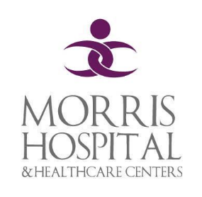

Medical

Executive Committee

General Medical Staff Committee

Professional Practice Evaluation Committee

Department of

Radiology & Pathology

Department of

Pediatrics

Department of OB & Gynecology

Department of Medicine

Department of Emergency Medicine

Transfusion Committee

Medical Records/UR Committee

Pharmacy & Therapeutics Committee

Department of

Surgery & Anesthesia

Trauma Committee

Cancer Committee

Immediate Care & Occupational Medicine

Interventional Cardiology Committee

Infection Prevention & Control

Stroke Committee

Code Blue Committee

Ethics Committee

Physician Assistance Committee

Quality Committee

Nominating Committee

Bylaws Committee